SAINT MARK'S CHURCH, REIGATE

NOTICE IS HEREBY GIVEN THAT THE ANNUAL VESTRY MEETING
WILL BE HELD ON SUNDAY 11 MAY 2025 AT 10.00AM FOR THE PURPOSE OF

- Confirming the Minutes of the 2024 Vestry Meeting
- The election of 2 Churchwardens
FOLLOWED BY THE ANNUAL PAROCHIAL CHURCH MEETING
FOR THE PURPOSE OF

- Recording apologies for absence
- Confirming the Minutes of the 2024 APCM
- The election of up to 4 Deputy Wardens
- The election of parochial representatives of the laity as follows:
- To the Deanery Synod 1 representative
- To the Parochial Church Council 3 representatives
- The appointment of an Independent Examiner
- To receive a report upon the financial condition of the parish for the year to 31 December 2024
- To receive a report upon the fabric of the church
- To receive a report upon the Electoral Roll of the parish
- To receive a report upon the proceedings of the Deanery Synod
- To consider any other matters of parochial or general church interest

All persons whose names are entered upon the Church Electoral Roll of the Parish and all persons whose names are entered on a register of Local Government Electors by reason of such residence are entitled to attend and vote at the Vestry Meeting.

ONLY persons whose names are entered upon the Church Electoral Roll are entitled to vote for members of the Deanery Synod or the Parochial Church Council.

Lay representatives to the Deanery Synod and the Parochial Church Council MUST be at least 16 years of age and MUST have their name on the Electoral Roll. Those proposing and seconding MUST also have their names recorded on the Electoral Roll.

The express consent of the proposed candidate is desirable, but not essential if, in the opinion of the Meeting, there is evidence of willingness to stand.

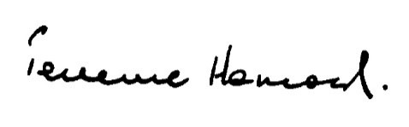

Honorary Secretary
Saint Mark's Parochial Church Council
April 2025

